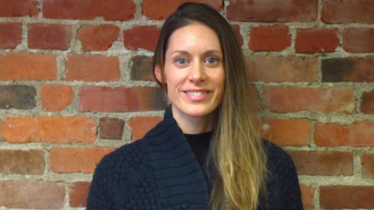  EXPERTISE  - Meeting Coordination  - Calendar Management  - Travel Logistics  - Marketing Research  - Notetaking  - Copy Editing  - Writing  CONTACT  206-583-0655  apaulsmeyer@triangleassociates.com  /triangleassociates/  www.triangleassociates.com  811 1st Avenue, Suite 255  Seattle, WA 98104 | Annalisa Paulsmeyer  Administrative Coordinator  PROFILE  Annalisa Peterson joined Triangle in 2017 in a dual hybrid role that supports the Administrative Team as well as the Facilitation, Mediation and Public Involvement Team. With nine years of certified teaching experience, Annalisa provides strong copy editing, document drafting and organizational skills. She is a confident research and logistics support person with an eye for detail and efficient planning capabilities. Annalisa provides reliable quick turn-around assistance with scheduling, document review, notetaking, copy editing, meeting planning and logistics as well as host of other projects.  EDUCATION  1998-2001 B.A. Dance University of Washington 2004-2006 Washington State Professional Teaching Certification, Elementary Education Seattle Pacific University  EXPERIENCE  Annalisa brings nine years of experience as a K-2nd grade classroom teacher and K-5th grade and special education dance specialist with Seattle Public Schools. During her most recent years of teaching she: designed and taught a schoolwide dance, yoga and creative movement curriculum, rehearsed students for performances, and stage-managed assemblies . Prior to working for Seattle Public Schools, she served as an Education Peace Corps Volunteer in Romania, teaching high school English conversation classes and creative movement to children with physical disabilities. Annalisa earned a BA from the University of Washington and a Washington State Teaching Certification through Seattle Pacific University.  PREVIOUS WORK EXPERIENCE  K-5th Grade and Special Education Dance Specialist  Seattle Public Schools, 2013-2016  K-2nd Grade Teacher  Seattle Public Schools, 2007-2013  Administrative Assistant / Receptionist  Alaska National Insurance, 2006-2007  Peace Corps Education Volunteer  U.S. Peace Corps, Romania, 2002-2004

