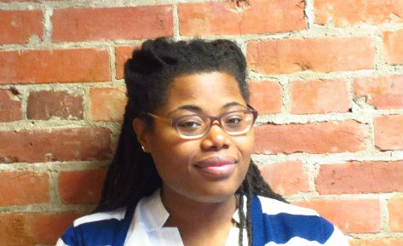  EXPERTISE  - Process and Workshop Facilitator  - Curriculum Development  - Event Planning & Coordination  - Community Engagement  - Volunteer Coordination  - Qualitative Data Analysis  - Research  TRAINING  - Change Management: Strategies for Leading Through Transitions, 2016  - Developing Your Company’s Training Plan, 2015  - Train-the-Trainer Diversity Leadership Institute, NCBI, 2015  - Restorative Justice, Restorative Circles, and Restorative Practices, 2015  CONTACT  206-583-0655  mmarnia@triangleassociates.com  in/marxamarnia  /triangleassociates/  www.triangleassociates.com  811 1st Avenue, Suite 255  Seattle, WA 98104 | Marxa Marnia  Project Associate II  PROFILE  Marxa Marnia joined Triangle in 2017 as a Project Associate II from the non-profit sector where she has largely focused on Diversity, Equity, and Inclusion and community development. Her work history includes process and workshop facilitation, committee leadership, event planning, volunteer coordination, and executive support. Marxa’s educational background is in environmental studies and political economy.  EDUCATION  2013 M.E.S. 2011 B.A.S.  Environmental Studies The Evergreen State College Liberal Arts The Evergreen State College  EXPERIENCE  KC Wastewater Treatment Division Strategic Plan, 2016-Ongoing  - Provides strategic support.  - Records and transcribes meeting minutes.  - Provides administrative support for overall project.  - Assists with documents and product drafting.  Portland Harbor Superfund Site, 2016-Ongoing  - Coordinates staff travel and meeting logistics.  - Prepares meeting documents.  - Greets and provides clear instruction and direction to the public.  - Assists with presentation: Q&A session, community member sign in, organization of meeting space and materials on an as needed basis.  - Drafts project reports and summaries.  Previous Work Experience  Training and Education Manager  Sound Generations, Seattle, 2014 – 2017  Research Assistant  Curriculum for the Bioregion, Seattle, Summer 2013  IT Technician I  The Evergreen State College, Olympia, 2010-2013  AmeriCorps NCCC Corps Member  Solid Ground, Seattle, 2008-2009  Program Assistant and Event Manager  Lifelong, Seattle, 2002-2006

